Component Name: Login

Component Description:

The Login component is responsible for authenticating users who wish to access the system. It verifies the user's identity based on their provided credentials (username and password) and grants access if the credentials are valid. If the credentials are invalid, appropriate error messages are generated and returned to the user interface. Upon login MFA is included so that dual security will be provided to the users.

Responsible Development Team Member: Novak Carter

Component Diagram:

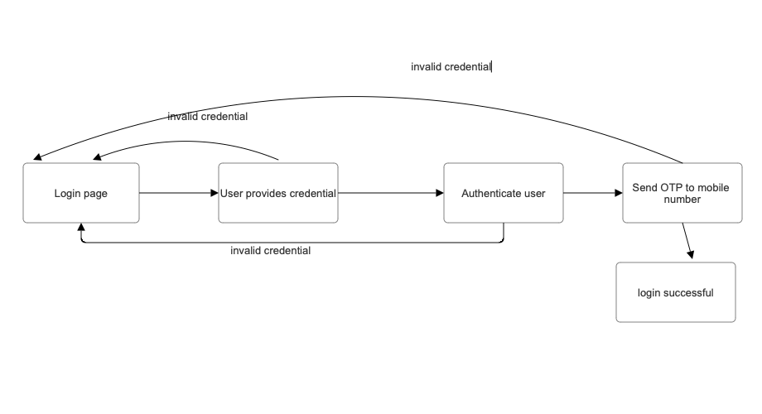

Component User Interface:

- Login Screen: This screen allows users to input their username and password.

- Error Messages: The component may generate error messages such asInvalid username or password" or "invalid otp" in case of incorrect input or other issues.

Component Objects:

- User class:

- Data Members:

- `username` (string): Stores the user's username.

- `password` (string): Stores the user's password.

- Methods:

- `authenticate(username, password)`: Verifies the user's credentials by comparing them with stored data.

- `verifyOTP()`: verify otp input from the user.

Component Interfaces (Internal and External):

- External Interface:

- The component receives user login requests through the user interface.

- It communicates with a database component to retrieve user credentials.

- Internal Interface:

- The component interacts with the User class to perform authentication.

- It may make operating system calls for tasks like locking user accounts.

Component Error Handling:

- Error Case 1: Invalid Credentials

- If the entered username or password is incorrect, the component will return an "Invalid username or password" error message to the user interface.

- Error Case 2: Invalid otp

- After a predefined number of failed otp attempts, the component cannot login back and need to start from scratch.

Component Name: Sign Up

Component Description:The Sign Up component allows users to create new accounts in the system. Users provide their personal information and create a username and password. The component verifies the provided information, creates a new account, and stores it in the database.

Responsible Development Team Member:Nithin Shastry Madhusudhana

Component Diagram:

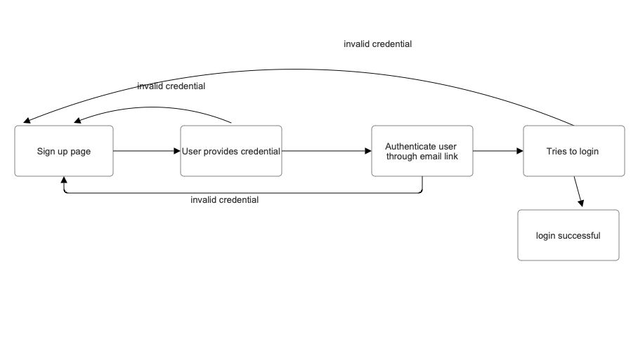

Component User Interface:

- Sign-Up Screen:This screen allows users to input their personal information, username, and password.

- Success Message: Upon successful account creation, a message like "Account created successfully and verify link via email" is displayed.

Component Objects:

- User class:

- Data Members:

- `username` (string): Stores the user's username.

- `password` (string): Stores the user's password.

- Methods:

- `createAccount(username, password)`: Creates a new user account and stores it in the database.

Component Interfaces (Internal and External):

- External Interface:

- The component receives sign-up requests through the user interface.

- It communicates with a database component to store user account information.

- Internal Interface:

- The component interacts with the User class to create and store user accounts.

Component Error Handling:

- Error Case 1: Existing email id

- If the chosen email already exists, the component will return an error message like "Email already taken."

- Error Case 2: Invalid Input

- If any of the provided information is invalid or incomplete, the component will return an error message asking the user to correct the input.

Component Name: Reset Password

Component Description:

The Reset Password component allows users to reset their forgotten passwords. Users provide their username and receive instructions for resetting their password, either through email or other means.

Responsible Development Team Member: Nithin Shastry Madhusudhana

Component Diagram:

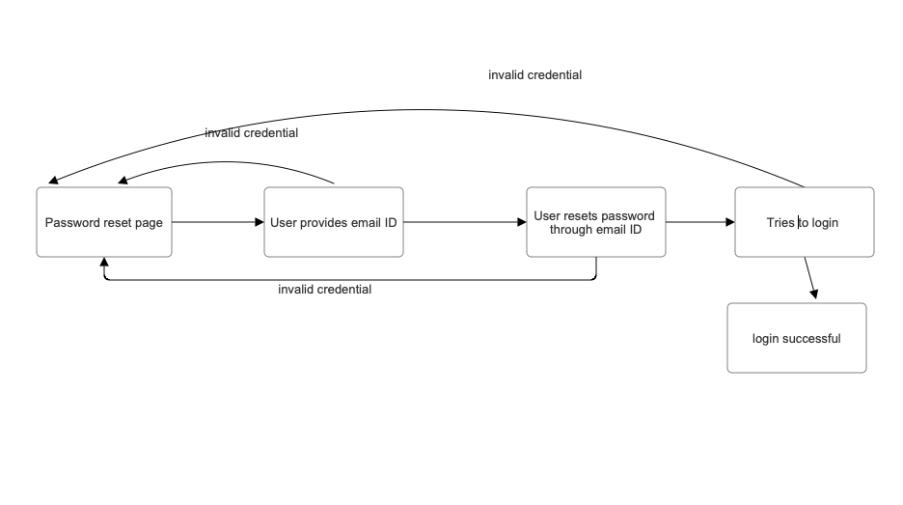

Component User Interface:

- Reset Password Screen: This screen allows users to input their user email.

- Instructions: After entering the user email, the component provides instructions for resetting the password, which will involve sending an email with a reset link.

Component Objects:

- User class:

- Methods:

- `resetPassword(username)`: Initiates the password reset process and sends instructions to the user.

Component Interfaces (Internal and External):

- External Interface:

- The component receives reset password requests through the user interface.

- It may communicate with an email system to send reset instructions.

- Internal Interface:

- The component interacts with the User class to initiate the password reset process.

Component Error Handling:

- Error Case 1: Communication Failure

- If there is a failure in sending reset instructions (e.g., email server issues), the component will return an error message indicating the communication problem.